Stat 130A Answers to (and comments on) Midterm II
F. J. Samaniego

1. (a) If X ~ Be(2, 2,), f(x) = 6x(1 – x)I_{(0, 1)}(x). P(1/4 < X < 1/2)
= 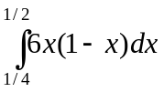 = 11/32.
(b) For X ~ Be(α, β), we can write EX = 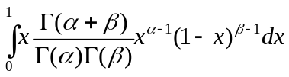
= 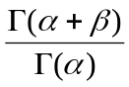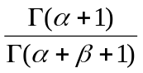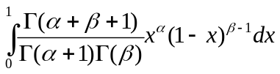= 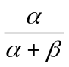.
2. (a) For x > 1, the cdf of a Par(θ) random variable is F(x) = 1 – 1/x^{θ}.
(b) Let F₁ be the distribution function of X₍₁₎. Then
F₁(x) = 1 – (1 – F(x))^{n} = 1 – (1/x^{θ})^{n} = 1 - 1/x^{nθ}, which is the cdf of a Par(nθ) variable.
3. (a) Solve 1 = 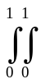kx³(1 – y)dxdy for k. The integral equals k/8, so k = 8.
(b) E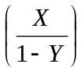 = 8x⁴dxdy = 8/5.
(c) P(X + Y < 1) = 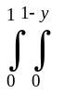8x³(1 – y)dxdy = 2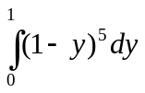= 1/3.
4. (a) f(y) = 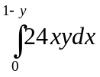= 12(1 – y)²y I_{(0, 1)}(y).
(b) f(x | y) = 2x / (1 – y)² for x (0, 1 – y).
(c) E(1/X | Y = y) = 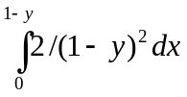 = 2 / (1 – y).

